No. 2-124/2010/RM-CM/BSNL Dated 01-04-2011

To

Chief General Manager/ IFA
All Territorial Circles/ Metro Districts. BSNL

Sub: Special Relief Scheme"SAMADHAN", for settlement of disputes in respect of high usage Bills of Wimax services, for the benefit of existing and ex-customers of BSNL-reg.
Ref: 1. No. 1-1/2009-R&C(CFA) dated 11.01.2010.
2. No.1-1/2009-R&C( CFA) dated 24.06.2010.
3. No.1-1/2009-R&C( CFA) dated 09.12.2010.

A kind reference is invited to the circulars cited above regarding introduction of Special Relief Scheme "SAMADHAN" for settlement of disputes in respect of Broad Band usage Bills for the benefit of existing and ex-customers of BSNL.

On the same terms and conditions, the "SAMADHAN" Scheme is approved by the competent authority for one time settlement of disputes in respect of high usage Bills of WImax Services for the period from 01.04.2011 to 31.05.2011.

An Immediate action may please be taken to settle the disputed bills and realise the Wimax outstanding dues. A compliance report on the implementation of this scheme with amount realized may also be furnished to this office by first week of June 2011.

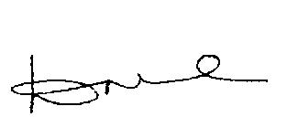

(D.Mohanakrishnan)
DGM(RM)-CM

